1. # Write a function that takes two numbers as input and returns their sum.

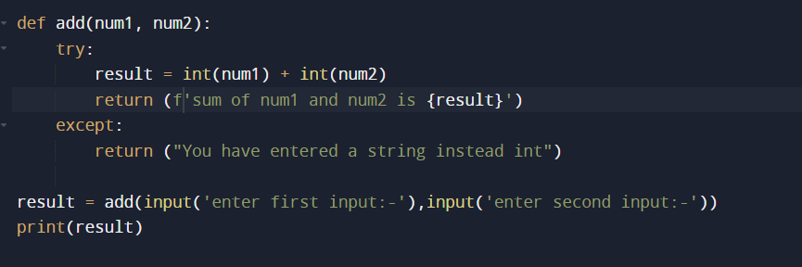

#EXPLANATION

1. We have defined a function add which takes two arguments
2. Inside the function we handled the errors using try and except blocj
3. If the user enter’s anything instead of integer, then we will return the message else we are returning the result
4. Returned result is stored in the function call variable ‘result’
5. This type of function calling is called, ‘CALL BY VALUE’, because we are calling the function directly by passing the values

#POSITIVE CASE

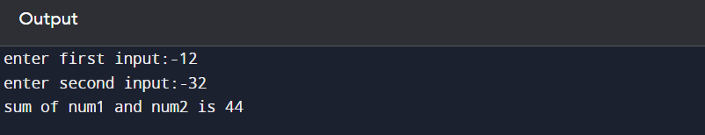

#NEGATIVE CASE

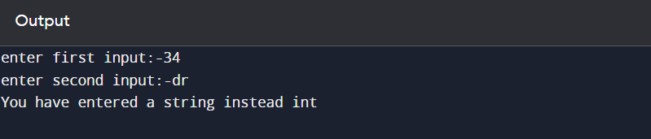

1. # Write a function that takes a list of numbers as input and returns a new list containing only the even numbers from the input list.

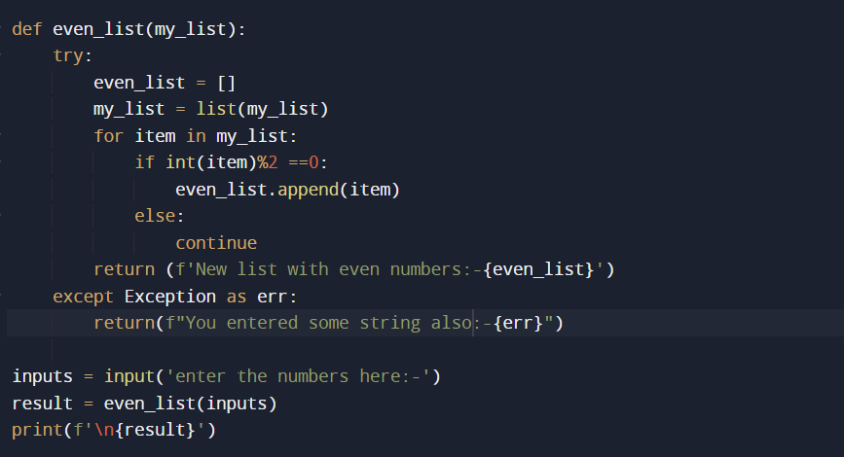

#EXPLANATION

1. We defined a function even_list which takes user inputs and convert them in to list
2. After converting the list, we are looping through each item in the list and checking if the item is even or not
3. If the item is even we are appending it to a empty list which we defined
4. If the item is not even we are just continuing the program
5. If the user enter’s any string instead of number’s we are prompting an error message using except block
6. Here, we are storing the user input into inputs variable and while calling the function we are sending the inputs variable as parameter
7. This type of function calling is called ‘CALL BY REFERENCE’

#POSITIVE CASE

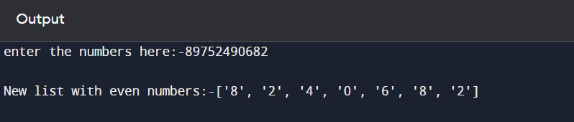

#NEGATIVE CASE

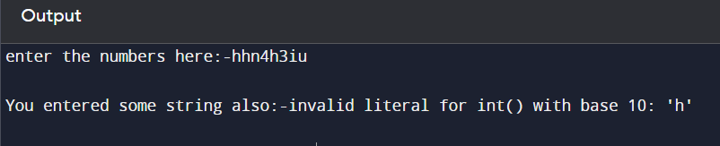

1. #Write a function that takes a list of strings as input and returns a new list containing only the strings that have more than 5 characters.

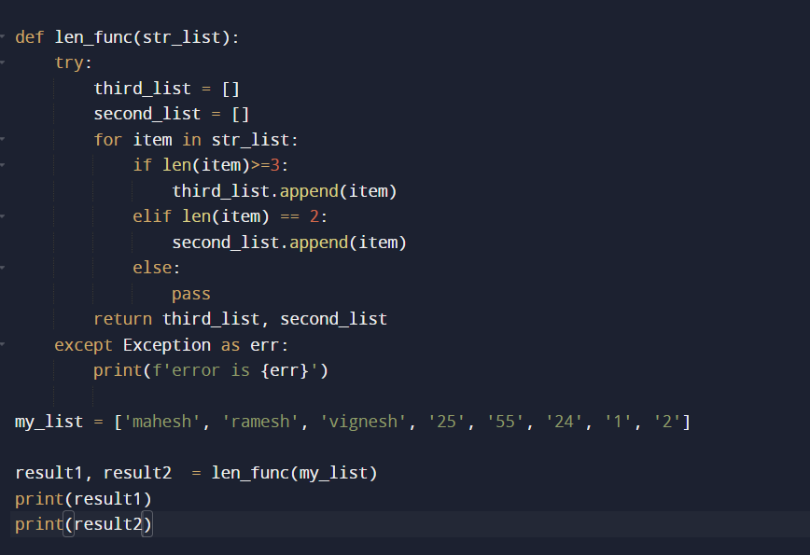

#EXPLANATION

1. We defined a function len_fuc which will separate the items based on the length and gives us in two different list
2. We are checking based on the length of the item and appending them
3. If the length is not equal to 2 or not more than three, we are doing nothing with that
4. Here we are returning both the lists in the single return
5. But while calling the function we are using two variables to store the two lists returned in the function

#OUTPUT

